Chapter 12, Solution 63.

Let 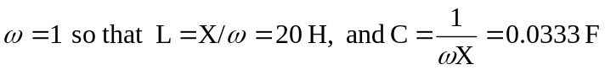
The schematic is shown below.. 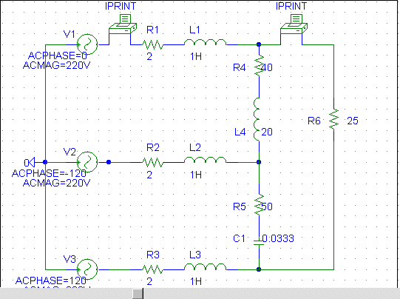 .

When the file is saved and run, we obtain an output file which includes the following:

FREQ IM(V_PRINT1)IP(V_PRINT1)

1.592E-01 1.867E+01 1.589E+02

FREQ IM(V_PRINT2)IP(V_PRINT2)

1.592E-01 1.238E+01 1.441E+02

From the output file, the required currents are:

